Name ________________________ HOMEWORK Dec. 5 - 9
Module 4 Week 3
Put your initials by each night that your child practiced the following:
____ Monday ____Tuesday ____Thursday
*Nightly Homework*
1. Count numbers 1-50.
2. Practice assigned Sight Word list in red reading folder.

MONDAY-Blend onset and rime into words.
Look at the picture. | Blend the onset and rime. | Write the word.
h
at
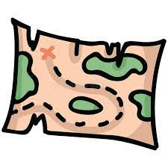 | ap  m
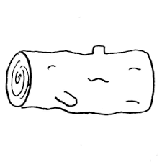 | og  l

Trace and practice forming the letters.
L l L l L l L l ______

H h H h H h ______
TUESDAY-
Read it. Trace it. Write it.
ram ram ____ dab dab ____
fat fat ____ fan fan ____

A period is a mark at the end of a telling sentence. Circle the periods.
1. The cat sat on the mat.
2. The man has a map.
3. The sun is hot.
Write a telling sentence. Start with an uppercase letter. Put a period at the end.
____________________________________________________________
THURSDAY-Write the -ot word for each picture.
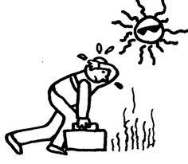  ______ | 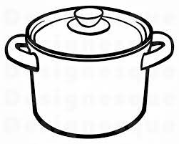  ______
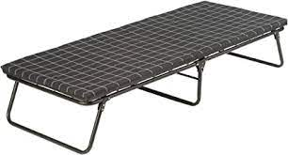  ______ | ______

Read the word circle the picture.
ham  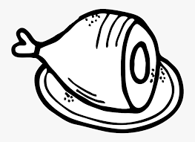 | top | leg  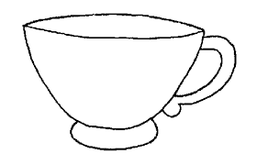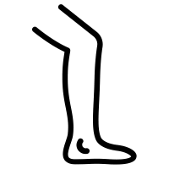

Start Right Reader Module 4 Week 3
Words to Know
was
lot
are
not

Kids Hid
Fit kids ran laps. “Not bad, kids! Not bad.” “Hop, kids, hop! Hop a lot! Not bad, kids! Not bad.” It was hot! The kids sat on a log and had a sip. Lin was not hot. “Hop, kids! Hop! Hop! Hop! “Kids! Kids! Kids! Are you here, kids?” The kids hid in the log! “Here you are, kids!”

